Teaching Portfolio
11214257
廖珮辰

Table of contents
01 | Teaching theories and practices………………………………….. | 2
02 | Service Learning on 4/10...……………………………………….. | 3
03 | Lesson Plan...…………………………………………................. | 5
04 | Materials………………………………………………………………. | 19
05 | Reflection on the Service Learning……………………………… | 24

Teaching theories and practices
Our lesson plan mainly applies a teacher-directed approach, in which the teacher leads the lesson and invites students to speak when needed. According to Shin and Crandall, this method can be effective by checking whether learners understand and can provide controlled speaking exercises to them (2013). Therefore, we use the “repetition” skill to help students improve their pronunciation and provide speaking opportunities. For instance, during the warm-up and presentation section, we will continually invite students to repeat each letter and word we teach. In this way, students can develop accurate pronunciation and be more willing to speak in English class.
Moreover, in order to help students recognize what they learn, we apply Piaget's Cognitive-Developmental theory. Based on the theory, we can use visual images to help students create schemas of letters. According to Piaget's theory, individuals have schemas, which are cognitive structures representing their thoughts (2014). That is, when people acquire new information or experiences, they assimilate them into existing schemas, helping them understand and interpret new situations. Therefore, students may be more skilled at learning new words and constructing higher language proficiency.
Furthermore, adding game-based activities may help students to be more focused and motivated in language learning. Annamalai et al. (2021) found that group work games in language lessons can help learners learn actively and interactively by sharing knowledge and receiving feedback. So, in the activity part, we assigned students to three groups to play the speed game. In this way, they can assist each other and improve their recognition of letters and vocabulary together. Also, with the positive reinforcement in each section, we believe that students can gradually build confidence and enjoy learning English.

Service Learning on 4/10
Before starting the course, we prepared some worksheets for the students to fill out. By using fill-in-the-blank exercises with pictures, we aim to assess the students' understanding of the vocabulary. We hope to use this information as a basis for designing our teaching materials. Below are the contents of our worksheets.

After-school activities eSTAR8 Unit 1
  play ________ |   play the _______
  read ___________ |   bake _________
  go _________ |   go _________

go __________

Lesson Plan
- Date and Time of the Teaching : 5/8 (三) 3:00 ~ 3:40

- Learning Objectives
- Prior Knowledge (先前知識)
- Students know the sequence of alphabets
- Students are familiar with the pronunciation of letter Aa-Nn
- Students are familiar with the phonics Aa-Nn
- Students know the upper and lower case of Aa-Nn
- Core Competence (核心素養)
- 英-E-A1
Possess favorable living habits, promote sound physical and mental development, identify one’s aptitudes, and develop potential talents.
(具備認真專注的特質及良好的學習習慣，嘗試運用基本的學習策略，強化個人英語文能力。)
- 英-E-B1
Possess the basic language competencies (i.e., listening, speaking, reading, writing, and composition) and be empathetic for others during interpersonal.
(具備入門的聽、說、讀、寫英語文能力。在引導下，能運用所學、字詞及句型進行簡易日常溝通。)
- 英-E-C2
Possess the ability to understand the feelings of others and show willingness to interact with others and cooperate with group members.
(積極參與課內英語文小組學習活動，培養團隊合作精神。)
- Learning Performance (學習表現)
- 2-III-10
Can read simple rhymes aloud and sing simple songs
(能複誦和吟唱簡易的歌謠韻文。)
- 5-II-1
Can recognize, read and take dictation of the 26 letters of the English alphabet.
(能正確地認讀與聽寫26個字母。)
- 6-II-1
Can focus on the teacher’s explanation and demonstration.
(能專注於教師的說明與演示。)
- 6-III-2
Enjoys participating in various class activities and demonstrates openness to trial and error.
(樂於參與課堂中各類練習活動，不畏犯錯。)
- 8-III-1
Can understand how people greet each other at home and abroad.
(能了解國內外基本的招呼方式。)
- Learning Content (學習內容)
- Aa-II-2
印刷體大小寫字母的辨識及書寫。
- Ae-III-1
簡易歌謠。
- B-III-2
國小階段所學字詞及句型的生活溝通。
- C-III-1
國內（外）招呼方式。
- Teaching Objectives (教學目標)
- Cognition: (認知)
- Students can say the letter Oo-Tt
- Students can recall the letters they have learned before (Aa-Nn)
- Students can sequence the letter from Aa-Tt
- Students know the vocabulary about Oo-Tt and say it out
- Emotion: (情意)
- Students can find learning English interesting through game-based teaching.
- Students can be braver to speak out the what they learn
- (Willing to practice their oral skills – pronunciation)
- Students can accept and respond in both Chinese and English
- Students can try to cooperate with others in class activities
- Skills: (技能)
- Students can fully practice the letters Oo-Tt through four skills.
- (speaking, listening, reading, writing)
- Students can have good pronunciation of the letter Aa-Nn.
- Students can distinguish the upper case and lower case of letters.
- Students can try to build basic vocabulary skills through courses.
- Vocabulary words and Sentence Structures taught
- Alphabets:
- Teach Oo, Pp, Qq, Rr, Ss, Tt
- Review Aa-Nn
- Go through the sequence of 26 letters
- Vocabulary
- orange
- pig
- queen
- red
- snake
- toy
- Materials Needs and number of the materials
- Letters cards in A4 sizes (uppercase & lowercase)
- Oo, Pp, Qq, Rr, Ss, Tt (1)
- Aa-Nn (1)

- Vocabulary words/ pictures in A4 size (both Chinese & English)
- orange/ 柳橙 (1)
- pig/ 豬 (1)
- queen/ 皇后(1)
- red/ 紅色(1)
- snake/ 蛇 (1)
- toy/ 玩具(1)

- Blank A4 paper booklet (15)
- Small flashcards of letters O-T and vocabulary (size: 9cm×9cm = about 1/6 A4 paper)
- Oo, Pp, Qq, Rr, Ss, Tt (5)
- orange, pig, queen, red, snake, toy (3)
- The Alphabet Chant – YouTube (1)

- Classroom English
- Warm up:
- Good afternoon, everyone.
- Let’s listen to the song.
- Presentation:
- Let’s read out loud.
- Repeat after me.
- Please write.
- Practice:
- Let’s play a game.
- Are you ready?
- Give me…
- Good Job! / Great! / Well done!
- Clap your hands.
- Wrap up:
- Let’s sing this song.
- That’s all for today!
- Goodbye, everyone.
- Management:
- Attention!
- Quiet, please.
- Procedures (with detailed script)
Stages | Activity and a Script | Time allotted | Materials Needed | Assessment
Warm-up/ Attention getters | - Say Hi & Introduction  e.g.  T: Good afternoon, everyone.  午安  S: Good afternoon./ 午安  T: I’m Cristine.  I’m Lala.  T: 若記不起名字，你們可以  叫我們老師  T: 今天我們要來學習字母  Oo-Tt 和複習之前教過的  字母。  T: 上課途中有問題可以舉  手發問(raise your hand)  - The alphabet chant  Teacher guides students in reviewing the sequence and pronunciation of alphabets  e.g    T: Let’s listen to the song.  大家先聽一次ABC歌，請注意聽字母的唸法及順序，之後會請大家一起唸一遍。  - T gives the lowercase flashcard a-n to Ss and asks to match the corresponding uppercase on the blackboard  e.g.  T: 我們來複習一下上次教過  字母，請將手上的小寫字  母放在正確的大寫字母的  下方。  Ss: (put the letter card)  - T guides Ss to read out the letters Aa-Nn again.  e.g.  T: Everyone! Repeat after me  大家跟著我一起唸喔  A…B……N  Ss: A…B……N | 2 mins  1 min  5 mins  1 min | - YouTube.  - A4 paper Aa-Nn cards.  (uppercase/ lowercase) | - Participation  - Oral Evaluation
Presentation  &  Practice | Presentation:  - T gives the blank A4 paper booklet to Ss  e.g  T: 每個人都拿到空白小書，請在空白書封面寫自己名字，接著在每一頁寫下所教到字母及單字  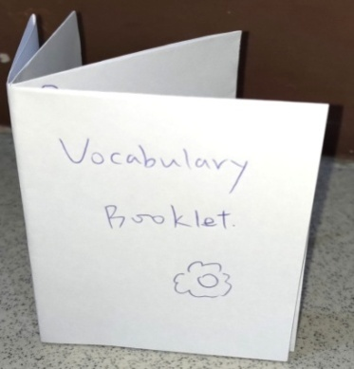  ※ Letter & Vocabulary  (一個字母一個單字依序教)  - T teaches the correct space of uppercase and lower letters Oo-Tt and invites students to write down  e.g  T: 請翻開第一頁，有看到左  上角有三條線嗎? 這是  要給你們練習寫字母。  T: 我們現在來看 big O 的位  置，有看到它位於第一條  和第三線之間嗎?  T: (Write down big O)  Please write big O  請把大寫O 寫在左上角。  Ss: (Write down big O)  T: 寫好了嗎? 我們接著來看  small o 的位置，是不是  在第一條和第二條線  之間?  T: (Write down small o)  Please write small o  請把小寫o寫下來。  Ss: (Write down small o)  T: 寫好了嗎?  那我們唸一次字母  Repeat after me  big O … small o  Ss: big O …small o  - T teaches the related vocabulary: orange, pig, queen, red, snake, and toy, and invites Ss to guess the Chinese meaning  e.g.  T: 寫好了嗎?  接著我們來學O的單字。  T: O is for orange.  orange 的中文是什麼?  (這裡先把 letters cards上  中文遮住)  Ss: 柳橙  - T asks Ss to write down vocabulary words in the booklet  e.g  T: Please write the word  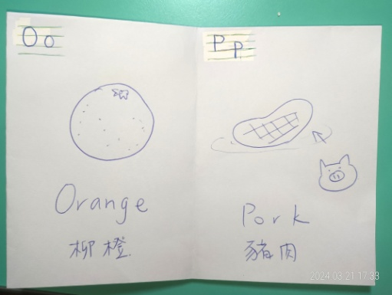  orange and 橘子。  請將 orange 的英文和中文單字寫下來，圖片等等下課可以畫。  (The following letters are taught in the same way as steps 2-4)  - T asks Ss to read out each letter and vocabulary  e.g.  T: Let’s read out loud.  big O…small o…orange  Ss: big O… small o…orange  Practice - Speed Game  Part 1- Letters  - T assigns students into 3 groups (4-5 people) and explains the rule.  e.g.  T: Let’s play a game!  一桌為一組，每組都會拿到字母卡片。待會老師會唸三個大或小寫字母，請你們找出這些卡片並交給我，先拿給我就得一分。  - T gives each group small  Oo-Tt flashcards.  - T says 3 letters in a round and asks each group to order the flashcards. Each group should listen to what T said and give target letters to the teacher. (The fastest group gets 1 point.)  e.g.  T: Are you ready?  Give me big P…R…T  請給我大寫P…R…T  Ss: (find the uppercase P, R, T  and give to the teacher)  - T invites Ss to say out the target letters after collecting the cards.  e.g.  T: Repeat after me.  大家請跟著我唸一次  big P… big R… big T…  Ss: big P… big R… big T…  Part 2-Vocabulary  - T gives each group small O-T vocabulary flashcards and explains the rule.  e.g.  T:每組都會拿到單字卡片，待會老師會唸兩個單字，請你們找出這些卡片並交給我，先拿給我就得一分。  - T says 2 vocabulary in a round and asks each group to pick them up.  - Each group should listen to what T said and give target vocabulary to the teacher. (The fastest group gets 1 point.)  e.g.  T: Give me sandwich, toy  (請給我sandwich 三明治, toy 玩具)  Ss: (find the sandwich & toy  card and give to teacher)  - T invites Ss to say out the target vocabulary after collecting the cards.  e.g.  T: Repeat after me.  大家請跟著我唸一次  sandwich… toy…  Ss: sandwich… toy…  - T counts the points that each group gets and invites Ss to clap hands.  e.g.  T: 我們總結一下分數，第 n  組獲得最高分。 Congratulations!  T: Clap your hands!  - 請給第一名掌聲鼓勵！ | 1 min  5 mins  4 mins  5 mins  1 min  5 mins  5 mins  1 min | - A4 paper Oo-Tt cards.  (lowercase/ uppercase)  - A4 paper vocabulary cards.  - Blank A4 paper booklet.  - Small cards of letter O-T/ vocabulary. | - Participation  - Oral evaluation  - Group Cooperation
Wrap-up/Closure | - T invites Ss to try to pronounce the letters O-T by themselves.  e.g.  T: 大家請自己唸一次黑板上  面的字母  (老師做為輔助也會一起唸)  S: O… P… Q… R…  - T invites Ss to try to read out the vocabulary by themselves.  e.g.  T: 大家請自己唸一次黑板上  面的單字  (老師做為輔助也會一起唸)  S: orange… pig… queen…  - T invites Ss to sing out the chant at the end of the session.  e.g.  T: Let’s sing this song.  結束課堂前，還記得一開始有聽一首歌嗎?大家一起跟著歌曲唸出來。  (老師做為輔助也會一起唸)  - Announce the content of the  next session & Say Goodbye  e.g.  T: That’s all for today.  T: 下一節將由其他老師帶大  家認識關於食物的英文~  大家也要專心上課喔~  T: Goodbye, everyone.  大家再見  S: Goodbye, Cristine & Lala  老師再見  備案)  T asks Ss to write down the uppercase and lowercase letters on their own on the last page of the booklet (for assessing)  e.g  T: 我們來練習今天學過的字母  ～翻到小書最後一面，按照  順序寫出大小寫O-T | 1 min  1 min  1 min  1 min | - A4 paper Oo-Tt cards.  (lowercase/ uppercase)  - A4 paper. vocabulary cards  - A4 paper Aa-Nn cards. | - Participation  - Oral evaluation

- Assessment
- Participation (參與度評量)
- Students should follow what the teacher says and pay attention to the instruction.
- Students are encouraged to respond and ask questions in the class.
- Students are encouraged to show their activeness in engaging the class.
- Students shouldn’t interrupt the class and follow the rules.
- Oral Evaluation (口語評量)
- Students can pronounce the letter and vocabulary accurately.
- Students can identify the letter and vocabulary and answer.
- Students follow the repetition each time and read out loud.
- Students can read out the letter and vocabulary individually.
- Group Cooperation (合作學習動態評量及小組計分)
- Students should work in the group and complete tasks in the class.
- Students should respect what the classmates said and give positive interactions.
- Students should collaborate effectively with classmates during group activities or discussions.
- Students can encourage quieter or less confident peers in discussions.

Materials
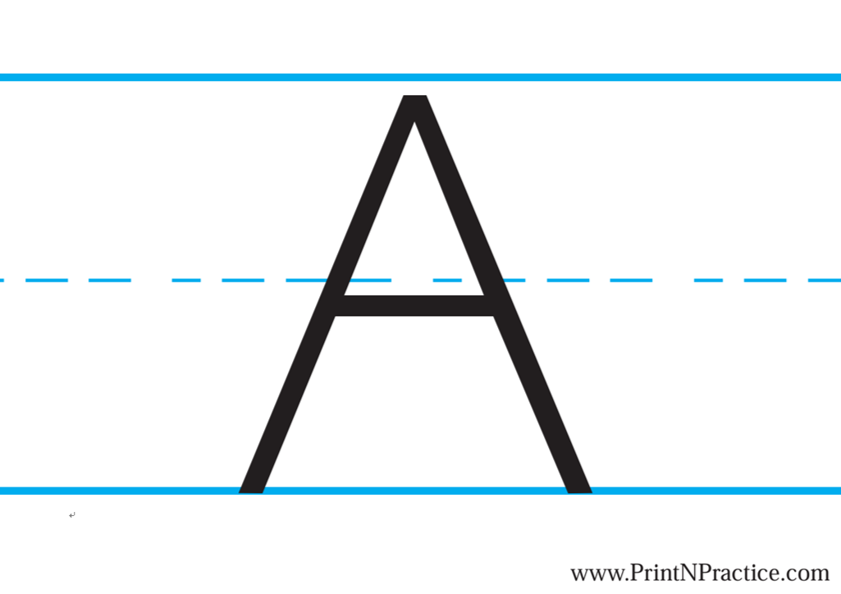
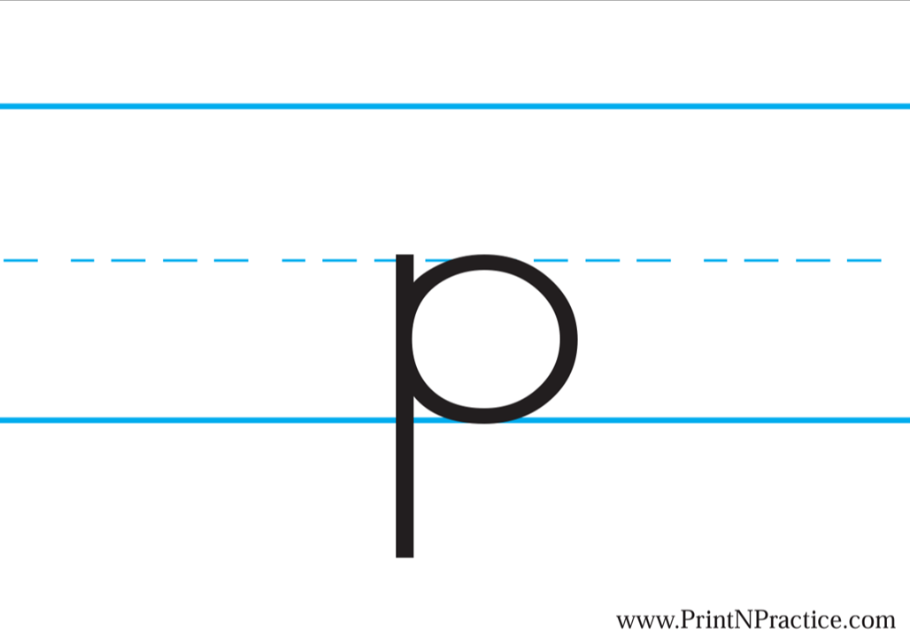
      - Letters Aa-Tt cards in A4 sizes (uppercase & lowercase)

      - Vocabulary words/ pictures in A4 size (both Chinese & English)
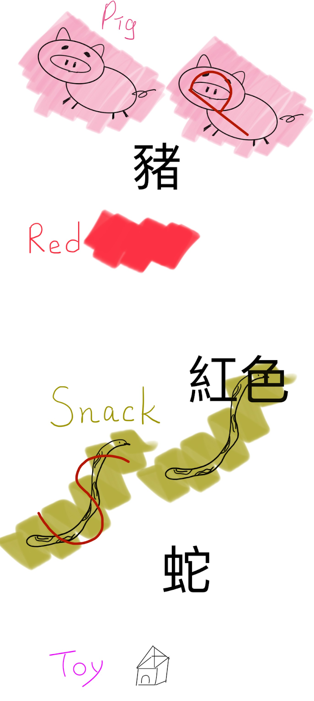
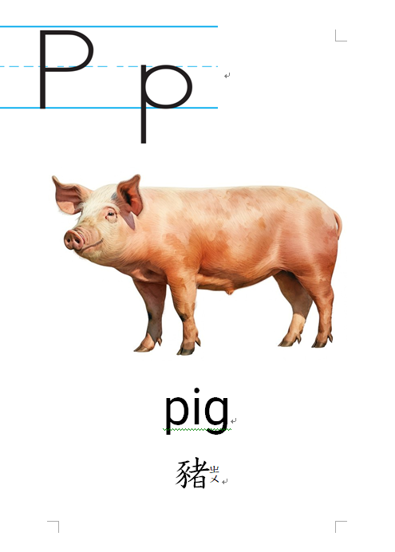

      - Blank A4 paper booklet
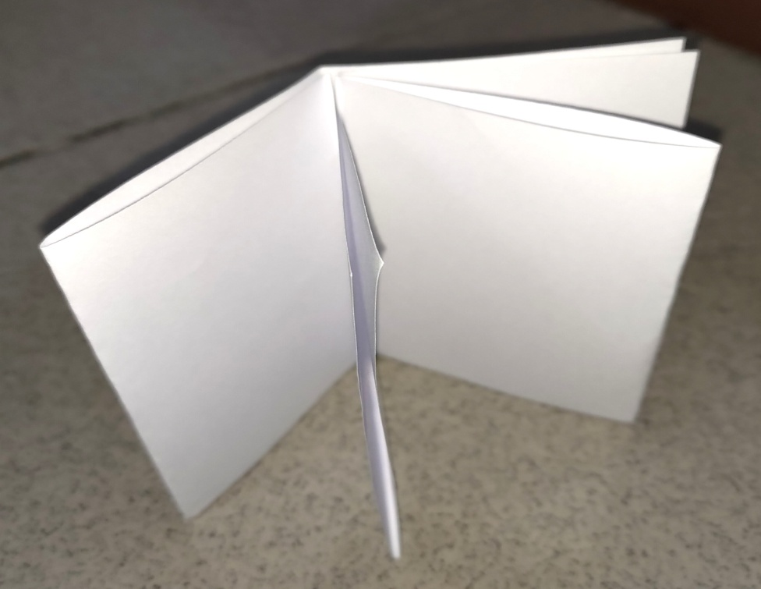

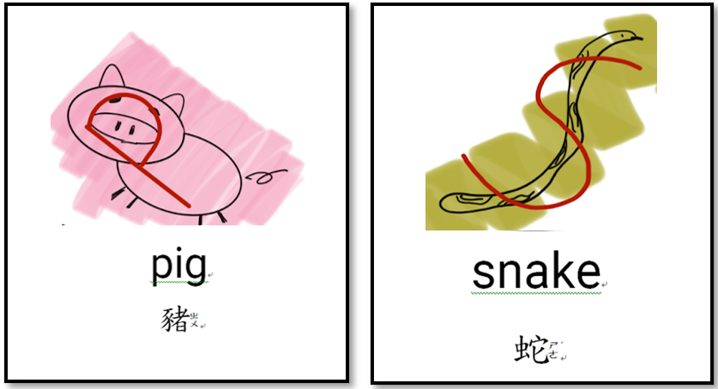
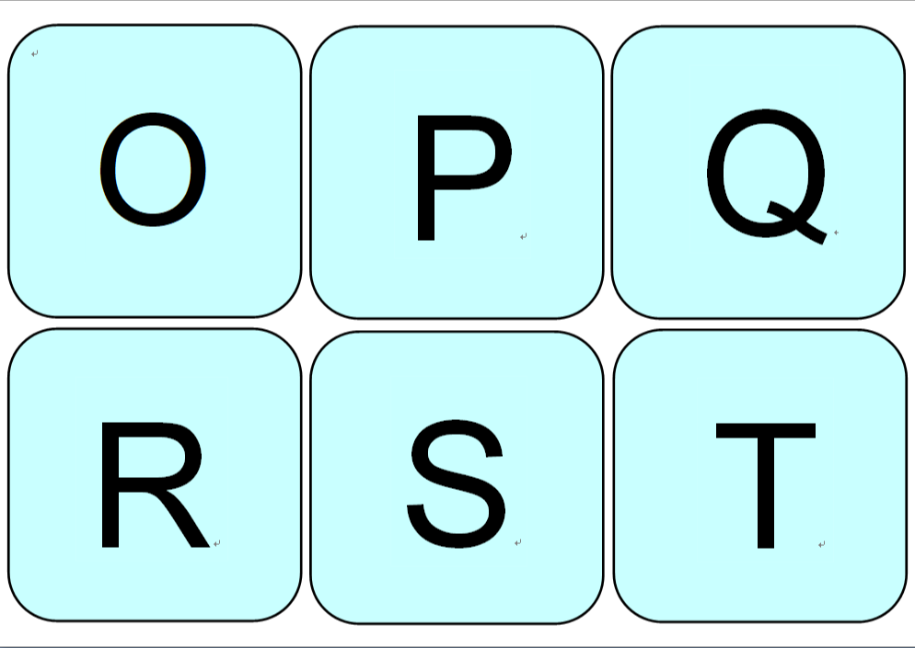
      - Small flashcards of letters O-T and vocabulary

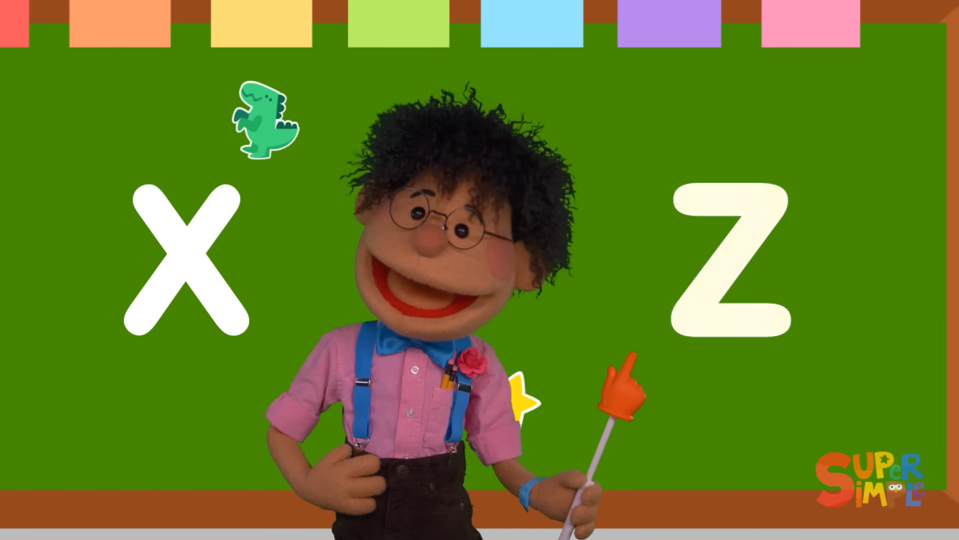
      - The Alphabet Chant feat. The Super Simple Puppets | Kids Songs | Super Simple Songs

Reflection on the Service Learning
First, I will outline the course flow using the Teaching Plan format, and then discuss merging it with my partner to create a unified plan. Because our teaching philosophy emphasizes pronunciation and letter recognition, we continuously adjusted our Teaching Plan in this aspect. For example, we chose some CVC (Consonant-Vowel-Consonant) structured words to use in our teaching, and we also utilized visual representations of the letters to aid students' memorization.
Following that, we each took turns to practice teaching, then selected a primary instructor and familiarized ourselves with the teaching process.
Finally, based on the Teaching Plan, we created teaching materials. To aid students' memorization, we incorporated hand-drawn illustrations of letters on our word cards. Additionally, to provide students with practice, we handmade mini books. To enhance students' motivation to learn, we encouraged them to memorize letters and words through writing and drawing activities in the books.
Aside from the unexpected smaller class size, which made managing the class more relaxed, our teaching mostly adhered to the planned schedule. However, we didn't emphasize enough on distinguishing between 'p' and 'q', which posed difficulties for some students during the games. We also missed the opportunity to properly address misconceptions during the games, which I feel was a missed opportunity.
Since the children are quite proficient, some of the content may seem a bit dull to them. It seems like we could add more challenge to our game content. Finding ways to make the games enjoyable while still educational is something I think I can improve upon.
The students were all engaged in learning, but each had their own pace and way of expressing themselves. Adapting to the situation and observing each student's condition was challenging. However, I feel that our teaching that day was quite successful; everyone learned something in class!

